* Created configuration to show disclaimer on product detail page
* Configuration Path
  + Stores->Configuration->Shadab->Settings->General->Product Disclaimer

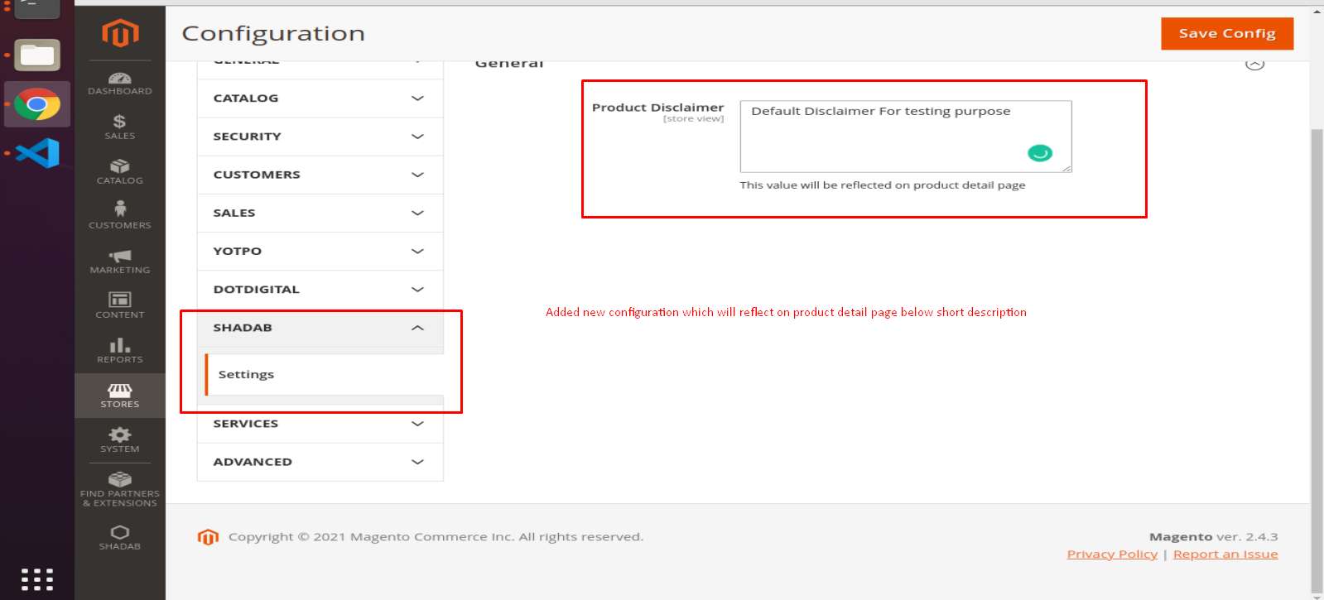

* The configuration data will show on product detail page

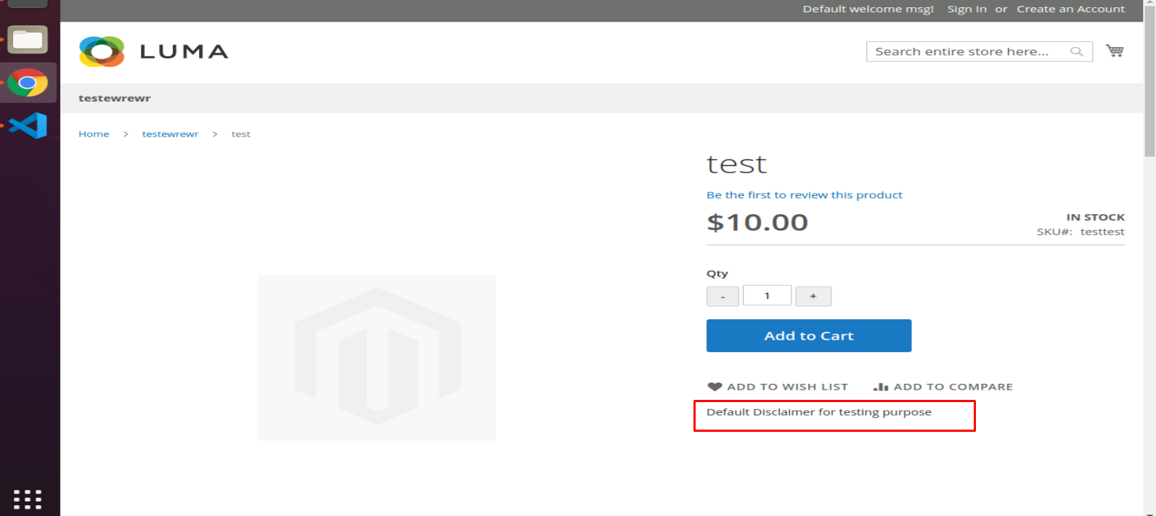

* Added ACL

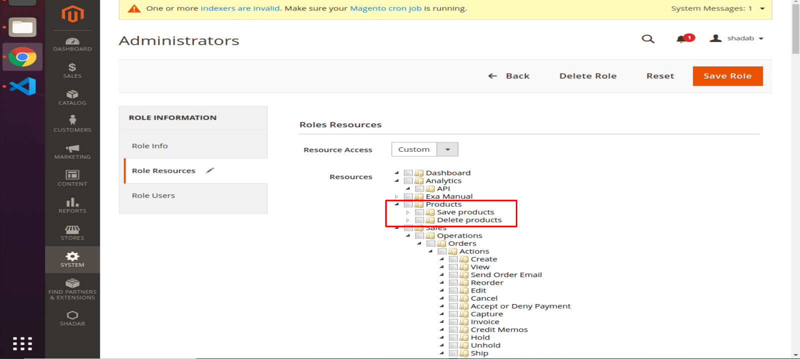

* Added Item in menu

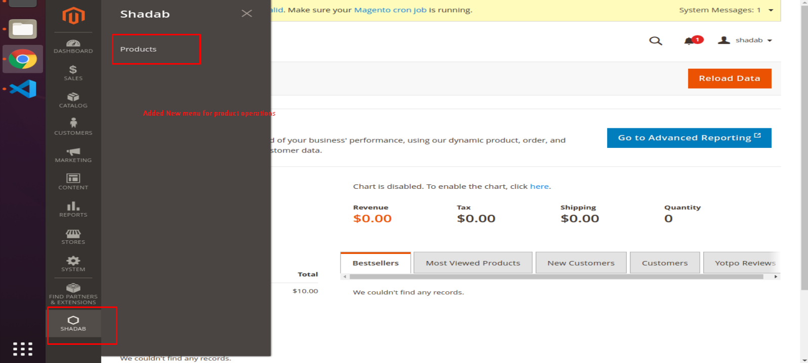

* Listing of the products

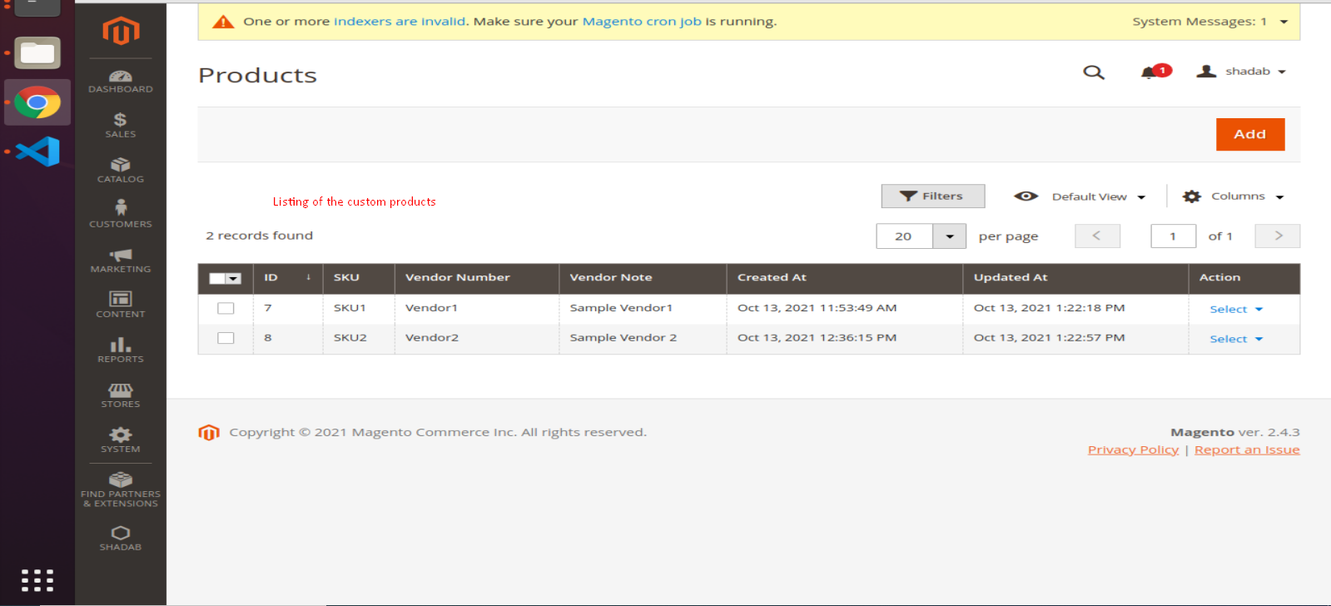

* Add New Product
  + When we are adding new product then first we will store on default level as Magento OTB does
  + Store level option will be not display on creating new product
  + After storing on default level we can save data on store view level
  + And for other store view if data is not updated then it will show default value

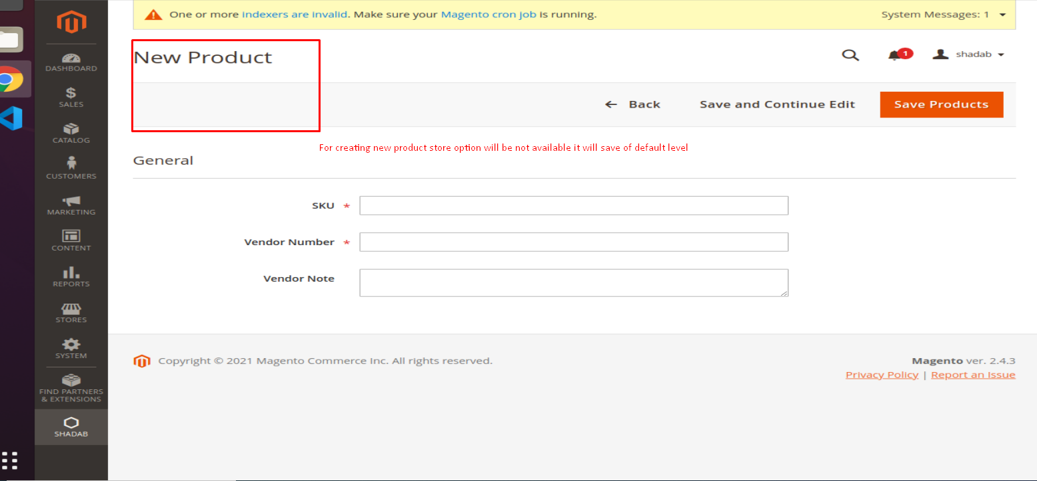

* Edit Product on default level

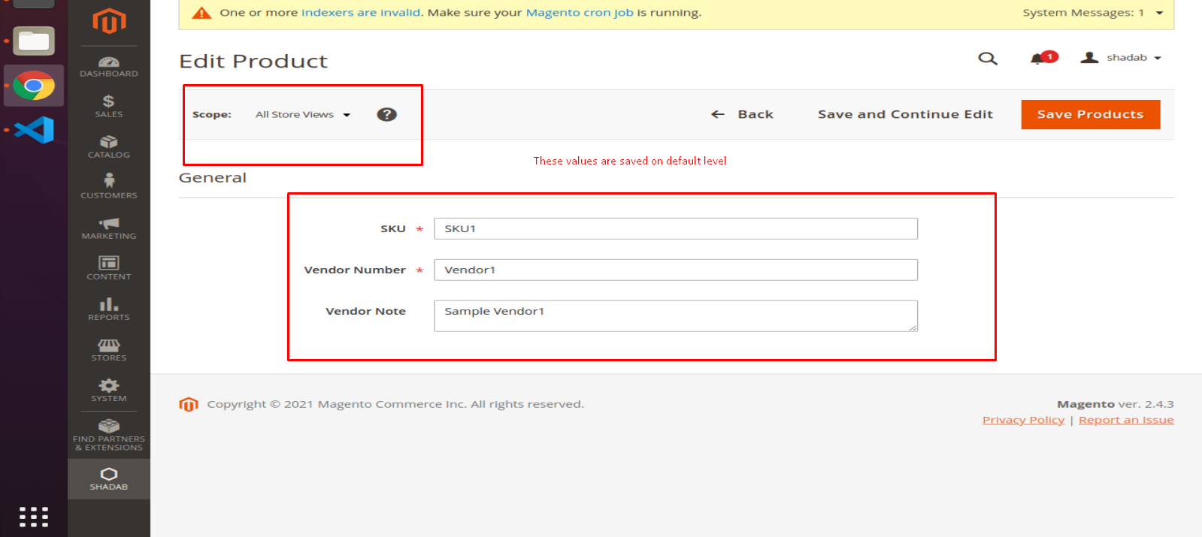

* Edit product on store view level

